Day 3: Evening assessment

1. Create an empty dictionary.



2. Create a dictionary with your name and age.



3. Add a key "city" with value "Hyderabad" to a dictionary.

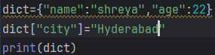

4. Access the value of key "name" from a dictionary.

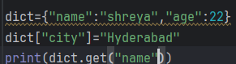

5. Change the value of key "age" to 30 in a dictionary.

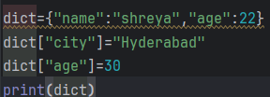

6. Delete the key "city" from a dictionary.

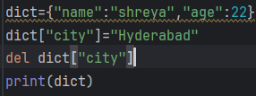

7. Check if key "name" exists in a dictionary.

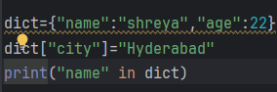

8. Get all keys from a dictionary using a method.

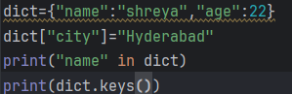

9. Get all values from a dictionary using a method.

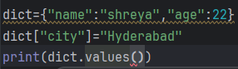

10. Get all key-value pairs from a dictionary.

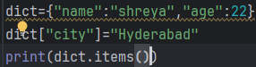

11. Use get() to access a key that exists.

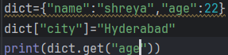output:22

12. Use get() to access a key that doesn’t exist and give default value.

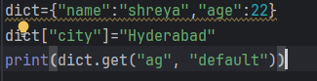output:default

13. Make a dictionary of 3 fruits and their colors. 

14. Update one key’s value using update().

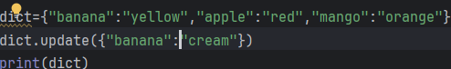

15. Remove a key using pop().

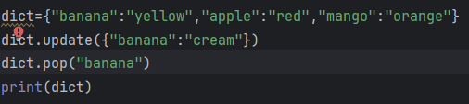

16. Clear all items from a dictionary using a method.

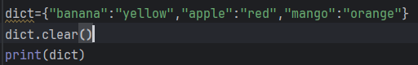OUTPUT:{}

17. Copy a dictionary using a method.

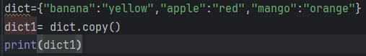

18. Write a loop to print all keys in a dictionary.

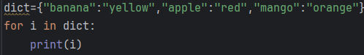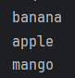

19. Write a loop to print all values in a dictionary.

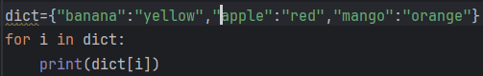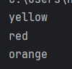

20. Write a loop to print keys with their values.

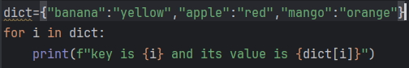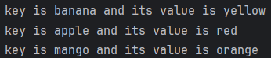

21. Make a dictionary with numbers 1–5 as keys and their squares as values.



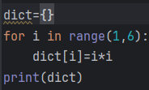

22. Count the number of keys in a dictionary using len().

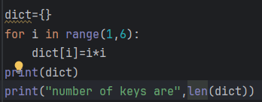

23. Merge two dictionaries using update().

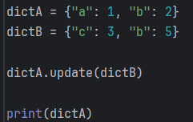

24. Make a dictionary of a student's name, marks, and grade.



25. Access a value using [] operator.



26. What happens if you access a non-existent key with []?

It will give us key error

27. What happens if you access a non-existent key with get()?

This will give None as the output

28. Check if a dictionary is empty.



29. Create a dictionary with mixed data types as values.

  
here the values are in the form of string, character and integer.

30. Loop over a dictionary and print values greater than 50.

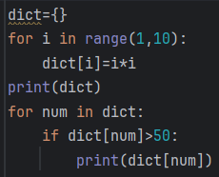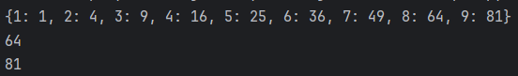

31. Write a program to create a dictionary from two lists (keys & values).

Zip is used for this operation

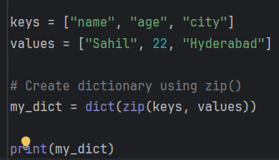

32. Write a dictionary comprehension for squares of numbers 1–5.



33. Add a nested dictionary inside a dictionary.



34. Access a value from the nested dictionary.

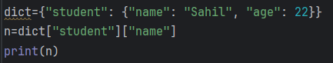output:sahil

35. Write a dictionary with duplicate values but unique keys.

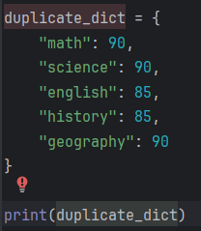

36. Explain the difference between pop() and del with example.

Pop(): it returns the value then removes the key  
del: deletes or removes the key

37. Write a program to find the maximum value in a dictionary.

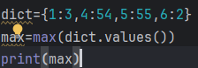output: 55

38. Write a program to sum all values in a dictionary.

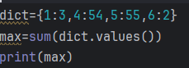

39. Write a program to find all keys with a certain value in a dictionary.\

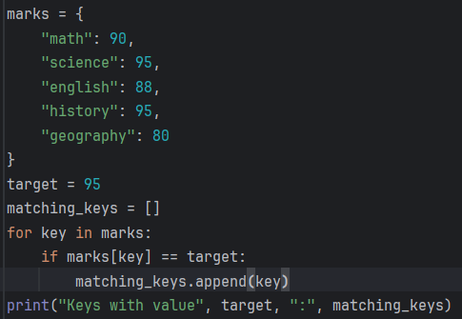

40. Write a program to count occurrences of each character in a word using dictionary.

